**Ideation Phase**

**Brainstorm & Idea Prioritization Template**

|  |  |
| --- | --- |
| Date | 19 September 2022 |
| Team ID | PNT2022TMID13417 |
| Project Name | Estimation of crop yield |
| Maximum Marks | 4 Marks |

**Step-1: Team Gathering, Collaboration and Select the Problem Statement**

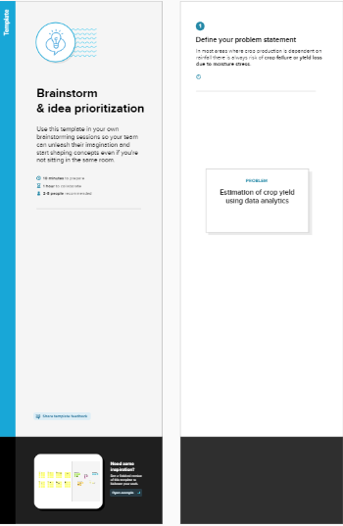

**Step 2: Gathering ideas:**

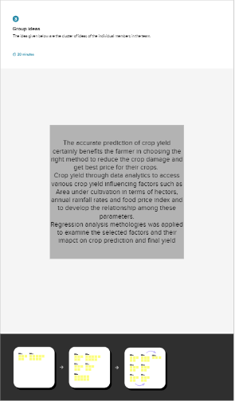

Step 3: main idea

